Elementary School: Grades 3-5
- Description:
Students will have the opportunity to watch three short entertaining videos about how water is wasted, what they need to do to save water and why water is so important. The class will then discuss the four main ways that water is used: at home, on fields for agriculture, for sanitation, and for drinking. Students will learn specific facts and calculations on water use and at the conclusion of the lesson; they will be given a water conservation checklist to take home with the challenge of how much water they can save.
- This lesson will address the following standards of learning:
Science:
3.1.a; 3.1.c; 3.1.d; 3.1.j; 3.6.a; 3.9.c; 3.9.d; 4.1.b; 4.1.d; 4.1.e; 4.1.f; 4.8.a; 5.1.c; 5.1.d; 5.1.e
Mathematics:
3.4; 3.10; 3.14; 3.15; 3.16; 4.6; 4.7; 4.9; 4.12; 5.4; 5.11.c; 5.12; 6.7; 6.9.c
English:
3.9; 3.10; 3.11; 4.7; 4.8; 5.8; 5.9; 6.6; 6.7

Objectives:
Students will:
- Understand the many ways in which water is wasted
- Know what water us primarily used for
- Learn specifics on water usage in America
- Be encouraged to save water in their own homes
Duration: 30 minutes

- (1.) http://www.youtube.com/watch?v=gtcZbN0Z08c

- (2.) http://www.youtube.com/watch?v=Fvkzjt3b-dU

- (3.) http://www.youtube.com/watch?v=kp_nyVPK4XQ

- Computer/Smartboard to play the videos

- One copy of the take home handout for each student
Teacher Background:
Water is wasted in countless ways in our world today from a person having a leaky faucet to a farmer using un-updated watering methods on his fields. Fresh water that is readily attainable and not in glaciers makes up only three tenths of a percent of the water found on earth, a place made of over seventy percent water. The process of getting clean water from a local river, lake, reservoir or aquifer to your sink is often overlooked, as it first goes to a water treatment plant and then to a storage tank and finally to the pipes that lead to our homes. Water is essential for life, and it is finite. Water conservation must be encouraged among all people to ensure that there is enough of this resource to last for generations to come.

Introduction: (to share with students)
An interesting idea: Americans, on average, use 100 gallons of water a day to do things like wash clothes and shower. The Chesapeake Bay has 18 trillion gallons of water in it, which is a whole lot. But there are 7 billion people in the world. 1,000 billion makes 1 trillion. So, if every person used 100 gallons of water in a day, the whole Chesapeake Bay would be gone in less than thirty days, because 700 billion times 30 is 21, 000 billion, or 21 trillion gallons of water. More water would be used in a month than all the water that exists in the Bay.

Lesson:
- Play the first video for the students, which is short cartoon with a boys sink running taking water from fish’s lake. This is a visual example of the effect of wasting water.

- Play the second video, which is from national geographic, and talks about the ways in which water is used and why it is crucial to conserve water.

- Explain the four ways in which water is used that the video talked about. Write Agriculture, Sanitation, Drinking, and At Home on the board.

- Tell the class that two thirds of the fresh water of the world is used for growing food, because crops need water to grow and people then eat those crops. Then explain that toilets for sanitation use 3.5 gallons of water per flush. Also explain that water in necessary for life and that all humans have to have fresh water to drink to survive. Lastly, write on the board that Americans use a lot of extra water in their homes every day: 26% of water use per day from the toilet, 22% on washing clothes, and 19% on showers and baths.

- Play the final video which demonstrates ways that students can conserve water in their own homes.

- Pass out the take home handout to each student, which is a checklist of ways that they saved water.

- Ask each student to do one of the things on the list for the next school day and to continue to conserve water in all the ways listed.

- Why is water important?

- In what four ways is water mainly used?
- How many gallons of water do Americans use each day?

- How is water used:
- In faming?
- Around the house?

- What can YOU do to save water?

I saved water in these ways:
- Turned off the faucet while brushing my teeth

- Turned off the faucet after washing vegetables and while cooking

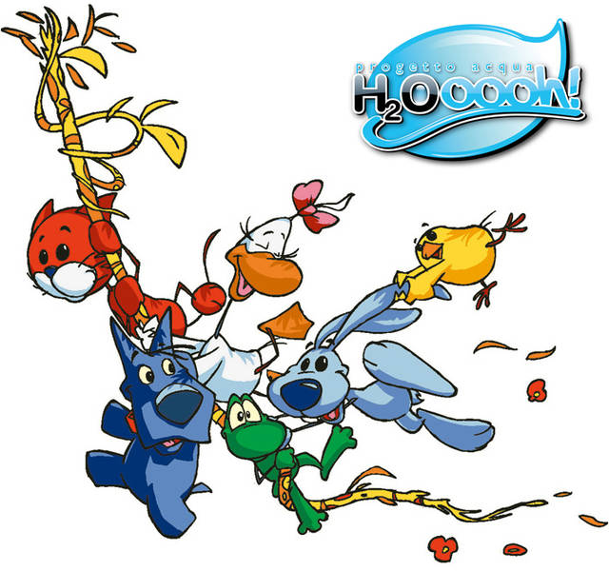
- Took a shower instead of a bath

- Drank all the water in my glass, so it didn’t go to waste

- Used unfinished water bottles to water houseplants

- Washed my parents car with a bucket and sponge, and turned off the hose

- Checked for leaky faucets or shower heads

- Told my family and friends how to conserve water

Signed:

