Elementary School: Grades 3-5
- Description:
Students will learn about Captain John Smith and compare the state of the bay in Smiths time in 1607, to how it is now. They will hear an excerpt from Smith’s journal and view a map of Virginia in the 1600s and a map of Virginia and the Chesapeake today. They will then discuss why the bay was important to the settlers and why it is important now.

- This lesson will address the following Standards of Learning:

Objectives:
- Students will:

- Compare the characteristics of the bay in the 17th century, to the bay today

- Read an excerpt from John Smith’s journal on his exploration of the bay and its tributaries

- View and analyze Smith’s map of the Chesapeake and compare it to a current map of the watershed

Duration: 30 minutes

- Provided excerpts from John Smith’s journal

- 1607 map of Virginia, one copy for each table

- 2012 map of Chesapeake Bay watershed, one copy for each table

Teacher Background:
In 1608 Captain John Smith made two voyages, leaving from Jamestown to explore the Chesapeake Bay. Smith wrote The General Historie of Virginia, New England and the Summer Isles, chronicling his experience among the land, waterways and native people, along with creating a map of the Chesapeake Bay and the country surrounding it. Smith describes the wildlife such as wolves, deer and birds as well as the clarity of the water and great amounts of oysters. Today, Virginia and the Chesapeake Bay are very different. The most notable changes include the lack of species variety along shoreline and in the bay, and the decline of water quality.

Introduction: (to share with students)
Captain John Smith sailed from Jamestown through the Chesapeake Bay and many of the rivers near it. He wrote about how clear the water was and explained that natives and settlers could use spears to catch the plentiful fish in the water. One day, while Captain Smith was spear fishing in the Rappahannock, he was stung by a sting rays poisonous tail. He thought that he was going to die from the sting and his men dug a grave for him, but he survived! Today, the site of the grave that was never needed is still known as “Stingray Point”. Do you think that there are so many sea creatures in the Chesapeake Bay today, where you could spear them or even get stung by them, by just wading in the water? Our bay is very different from the way it was when Captain John Smith was alive.

Lesson:
- After reading the introduction to the students ask them what they know about John Smith and inform them that Jamestown was the first English colony in America, and was settled in 1607.

- Have the students discuss the possible differences between the Chesapeake Bay in Smiths time, and the Chesapeake Bay today. Let them explain how the water might have looked or what the land was like, and make a list on the board.

- Choose a few of the excerpts from John Smith’s journal about the wildlife and natural features of the bay, and have a representative from each table or group of students read the description out loud to the class.

- Continue discussing how what Smith described in Virginia has changed over the centuries.

- Pass out a copy of the Map of Virginia and the Chesapeake Bay that John Smith made in 1608 to each table and let the students examine it. Point out the bay on the map.

- Pass out a copy of a current map of the Chesapeake Bay watershed and allow the students to compare the two.

- Conclude with discussing why the Chesapeake Bay was important to the settlers and why it is still important today. Included reasons such as trade routes, sanitation, and fishing.

- How is the Bay different today than it was in the 17th century?

- What were some of the things that John Smith wrote about in his journal concerning the wildlife and physical features of the region along the Chesapeake Bay?

- What are some of the differences between the map of Virginia in 1607, and the map of Virginia in 2012?

- Why was the Chesapeake Bay important to the settlers and still important to us in the 21st century?

Writing from John Smith, 1612

“Of fish we were best acquainted with sturgeon, grampus, porpoise, seals, stingrays whose tails are very dangerous, brits, mullets, white salmon, trouts, soles, plaice, herring, conyfish, rockfish, eels, lampreys, catfish, shad, perch of three sorts, crabs, shrimps, crevises, oysters, cockles, and mussels.”

“Of birds, the Eagle is the greatest devourer. Hawks there be of diverse sorts as our Falconers
called them, Sparrow hawks . . . Goss hawks, Falcons and Ospreys . . . In winter there are great
plenty of Swans, Cranes gray and white with black wings, Herons, Geese, Duck . . . Parrots, and
Pigeons. Of all those sorts great abundance, and some other strange kinds to us unknown by name.”

“Of beasts the chief are Deer, nothing differing from ours. In the deserts towards the heads of the rivers, there are many, but amongst the rivers few.”

“Their Bears are very little in comparison of those of Muscovia and Tartaria. The Beaver is as big as an ordinary water dog, but his legs exceeding short . . . His tail somewhat like the form of a Racket bare without hair . . . They have many Otters, which, as the Beavers, they take with snares, and esteem the skins great ornaments; and of all those beasts they use to feed, when they catch them.”

“By the rivers are many plain marshes containing some 20, some 100, some 200 Acres, some more, some less. Other plains there are few, but only where the Savages (Indians) inhabit: but all overgrown with trees and weeds being a plain wilderness as God first made it.”

“Virginia doth afford many excellent vegetables and living Creatures, yet grass there is little or none but what grows in low Marshes: for all the Country is overgrown with trees.”

http://www.johnsmith400.org/The_Chesapeake_Bay_in_1608.pdf

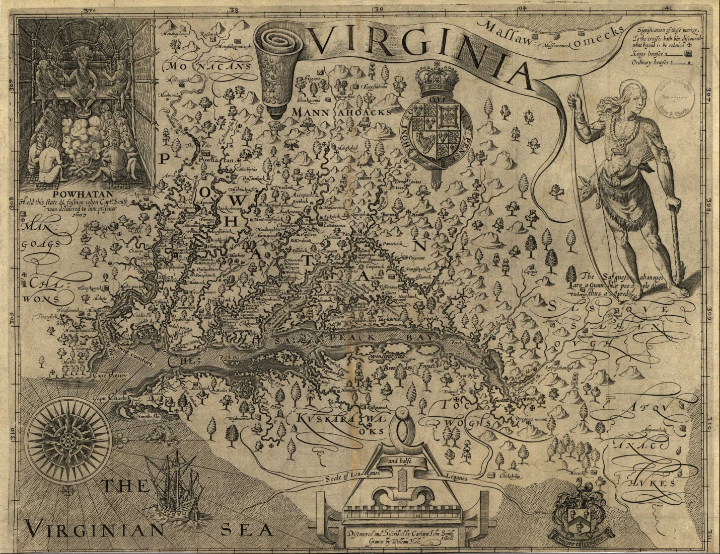
John Smith’s Map of Virginia

